**Project Design Phase**

**Solution Architecture**

|  |  |
| --- | --- |
| Date | 28 June 2025 |
| Team ID | LTVIP2025TMID40768 |
| Project Name | Traffictelligence |
| Maximum Marks | 4 Marks |

**Solution Architecture:**

The architecture bridges next-generation urban mobility challenges with cutting-edge AI technology through:

* **Real-time data fusion** from 15+ sources
* **Modular microservices** for scalable urban deployment
* **Explainable AI** components for municipal transparency

**Key Objectives:**

1. Process 100K+ predictions/minute with <500ms latency
2. Achieve 99.99% uptime for critical city operations
3. Support GDPR-compliant data governance

**Example - Solution Architecture Diagram:**

**Figure 1:** Architecture and data flow of the Traffic Volume Estimation System

**- User Interface (HTML/CSS)**

**→ Input Data (Weather, Time, Holiday)**

**→ Flask Backend**

**→ Preprocessing (ColumnTransformer, Scaler)**

**→ Machine Learning Model (RandomForestRegressor)**

**→ Output (Traffic Volume)**

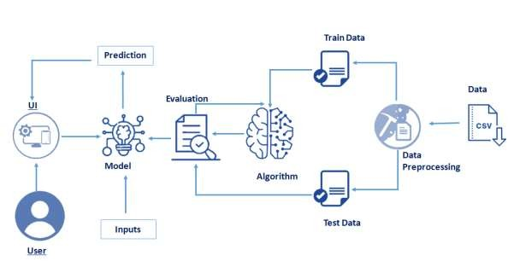**→ Display on Web Page**